HIEN AND HIS BOYS

Macklemore’s version of a bookshop

GET THRIFTY!

By: Hien and his boys

**Introduction:**

Our telegram bot would be a platform for students to buy and sell second-hand textbooks to one another at cheaper prices so as to allow buyers to purchase learning material at lower prices and sellers to earn back some cash for selling books they likely won’t use again.

**Problem Statement:**

Textbooks are generally a necessity in one’s education. However as one reaches university, textbooks may get very pricey. Although schools generally have second-hand book fairs to allow students to purchase books at lower prices, such sales for books seldom happens and more often than not a student ends up buying the textbook for full price or engage a carousell seller that may require him/her to travel out of the campus to make the exchange (NTU’s quite a secluded campus).

**Solution:**

Our telegram bot (by Hien, and his boys) aims to solve the above problem by creating a marketplace for students within NTU to buy and sell their second-hand textbooks to provide convenience in the acquisition of the books and also at affordable prices compared to buying them new.

**How it works:**

If you’re selling, input some key information in the book you’re selling (ie price, title, condition) and wait for a notification by the bot. The bot will pair you with a buyer that wants to buy said book. The process is similar if you’re buying: input key info and wait for a notification. One thing to note is that the bot only lists the price of the book the seller has set and it does not by any means facilitate any transactions between both buyers and sellers. The actual payment could be in any form that is agreed and settled between the buyer and seller once they have been paired.   
  
**How the process looks like:**

<Refer to next page>

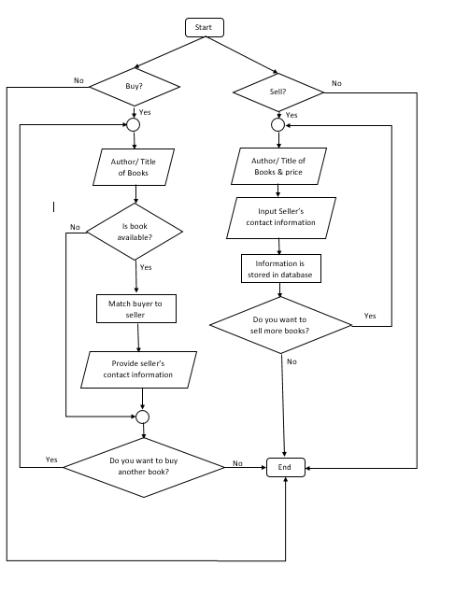  
  
**Constraints and limitations:**

One of the limitations we’ve taken into consideration is that the bot is only as effective as the people who use it; if nobody knows of the bot, there won’t be many sellers and buyers wouldn’t be able to find the textbook they’re looking for.

**Conclusion:**

In conclusion, we believe our telegram bot would be beneficial to the NTU student body by providing them with an easier and cheaper alternative to buying textbooks.